




In Partnership with St. Edward's Parish, Diocese of Victoria
Email: qa@cisdv.bc.ca Website: www.queenofangels.ca

APPLICATION CHECKLIST

Thank you for your interest in Queen of Angels Catholic School.
The following checklist will assist you in making a formal application to our school.

□ Application Form, fully completed and signed by both parents/guardians
□ $100.00 non-refundable application fee (per applicant)
□ Photocopy of student’s most recent learning update/progress report
□ Copy of Birth Certificate
□ Copy of Baptismal Certificate (if Catholic)
□ Recent photo of student
□ Authorization for Release of Information Form
□ Family Statement of Commitment Form (one per family)
□ Recommendation for Enrollment Form provided to current school (Grade 1-9 Applications)

Please submit your completed application along with the above-mentioned items to our office at your earliest convenience.
Thank you again for your interest in our school. We look forward to meeting with you in the future.
Please do not hesitate to contact our office should you have any questions.

Sincerely,
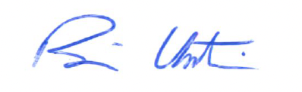
Mr. Brian Untereiner
Principal

2085 Maple Bay Road, Duncan, BC V9L 5L9 Telephone (250) 746-5919 Fax (250) 746-8689

